Gene Expression Analysis & Disease Relationship
UMAP Visualization Report — PyTorch Autoencoder

1. Overview
This report presents a dimensionality reduction and clustering analysis of a synthetic single-cell gene expression dataset. A PyTorch-based Autoencoder was trained to extract compact latent representations from six gene features, followed by UMAP projection to 2-dimensional space for visualization. Results are compared between raw normalized features and the 16-dimensional Autoencoder latent space.
2. Dataset Summary
Parameter | Value
Total Cells | 3,000
Feature Columns | 6 (5 gene expressions + 1 inflammatory pathway score)
Cell Types | T_Cell (1,000) / Cancer (1,000) / Fibroblast (1,000)
Disease Status | Tumor (2,595) / Healthy_Control (405)
Normalization | Z-score via PyTorch (per-feature mean / std)

3. PyTorch Autoencoder Architecture
The Autoencoder compresses 6-dimensional gene expression vectors into a 16-dimensional latent space through two hidden layers (64 units each, BatchNorm + ReLU). Training ran for 100 epochs with Adam optimizer (lr=1e-3) and StepLR scheduler, achieving a final MSE loss of ~0.006.
Layer | Input | Output | Activation
Encoder FC-1 | 6 | 64 | BatchNorm + ReLU
Encoder FC-2 | 64 | 64 | BatchNorm + ReLU
Encoder FC-3 | 64 | 16 | — (Latent Vector)
Decoder FC-1 | 16 | 64 | BatchNorm + ReLU
Decoder FC-2 | 64 | 64 | BatchNorm + ReLU
Decoder FC-3 | 64 | 6 | — (Reconstruction)

4. Autoencoder Training Loss
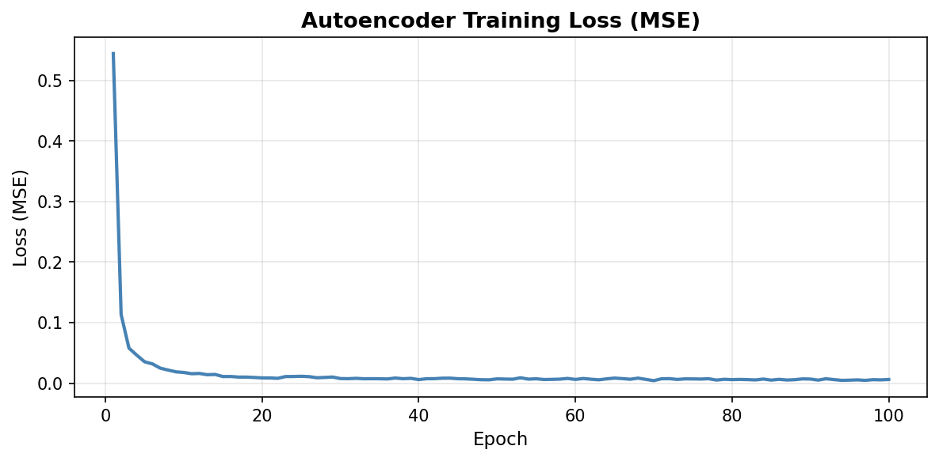
Fig 1. MSE loss curve over 100 training epochs.

5. UMAP Visualization
5.1 Raw Normalized Features
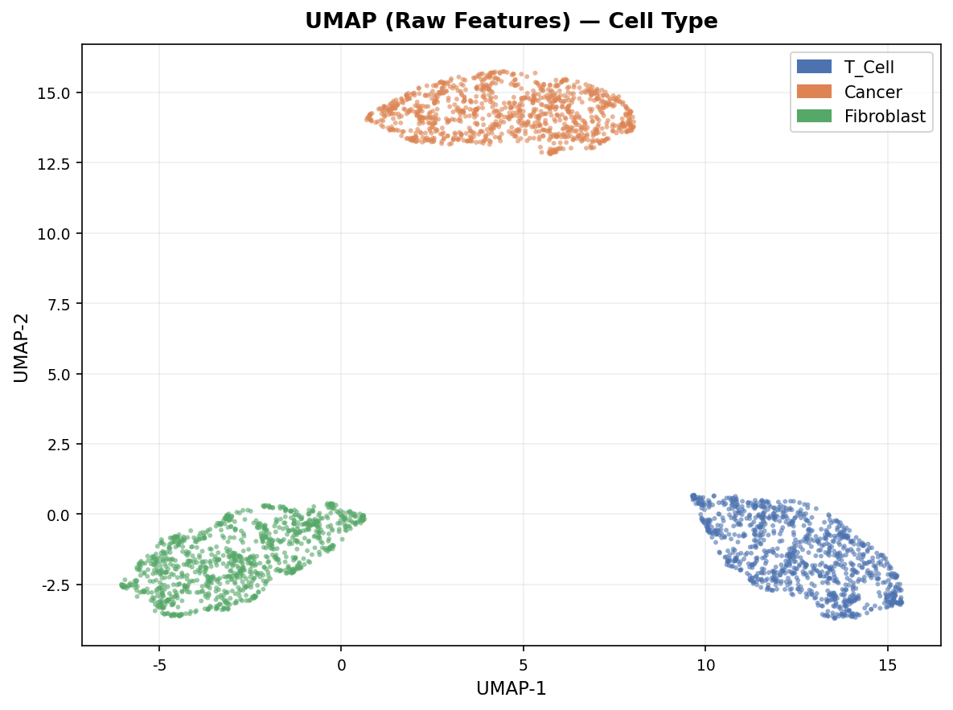
Fig 2. UMAP of raw features colored by Cell Type.
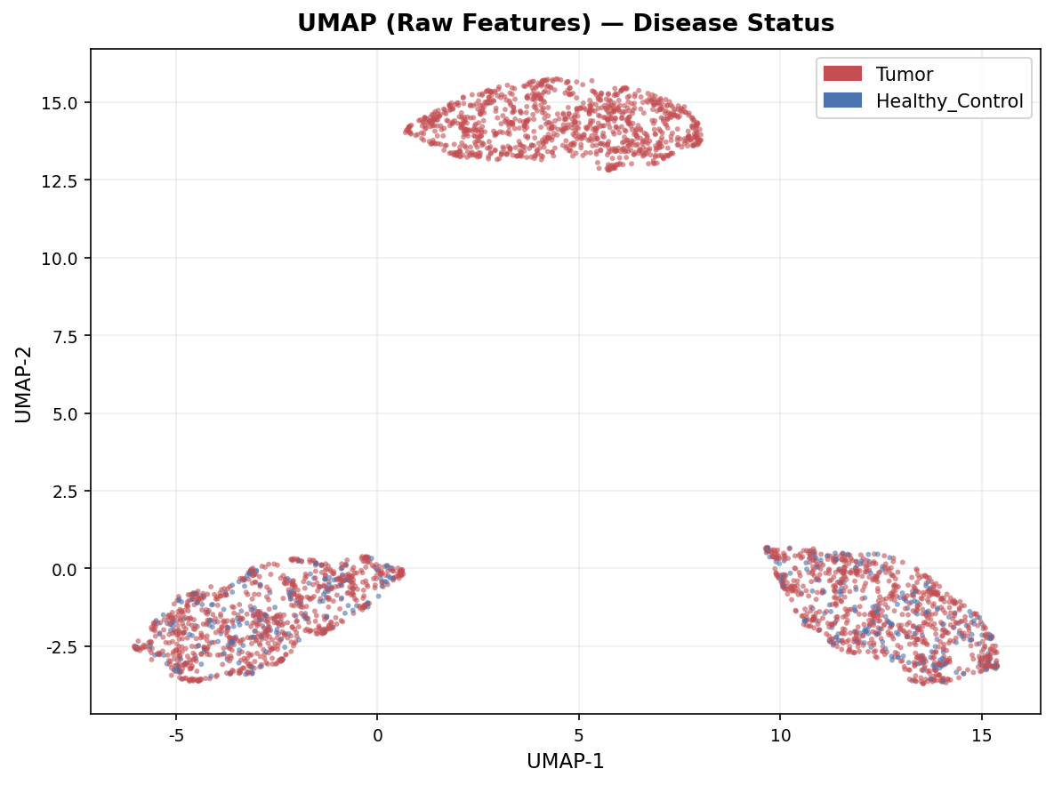
Fig 3. UMAP of raw features colored by Disease Status.

5.2 Autoencoder Latent Space
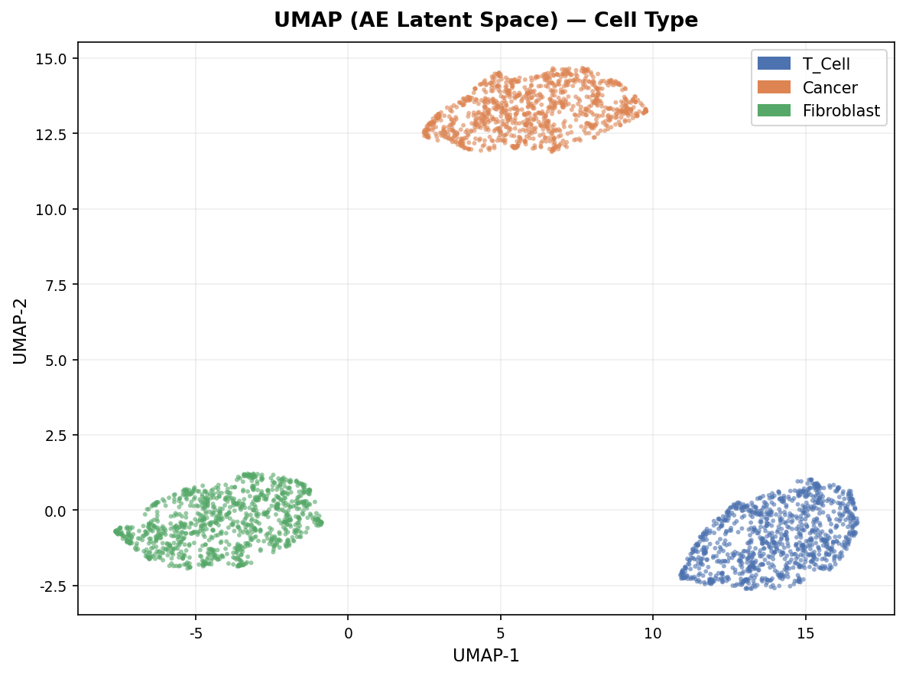
Fig 4. UMAP of AE latent space colored by Cell Type.
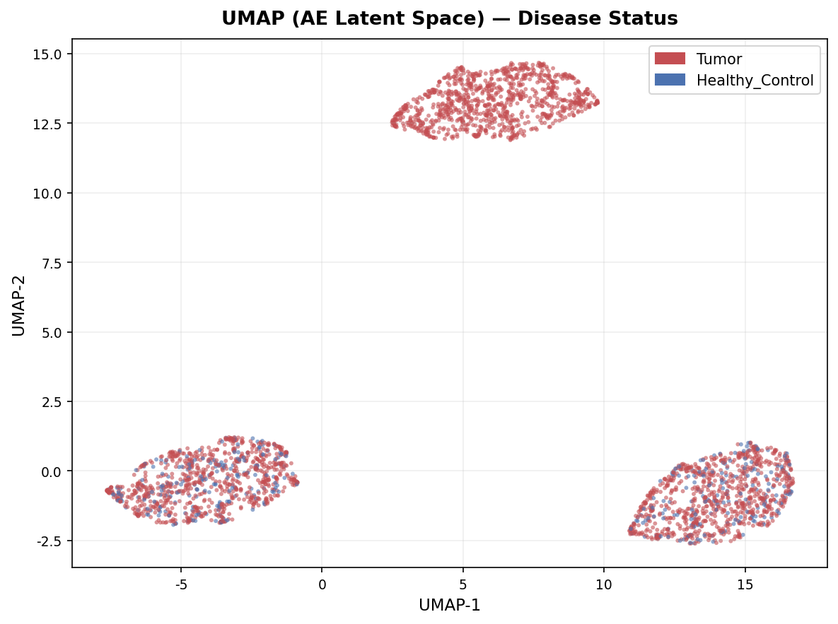
Fig 5. UMAP of AE latent space colored by Disease Status.

6. Gene Expression Statistics
6.1 Mean Expression by Cell Type
Group | HK | Oncogene | Immune | Stromal | Therapy | Inflam
Cancer | 5.002 | 14.005 | 2.966 | 3.510 | 9.961 | 6.624
Fibroblast | 5.010 | 4.010 | 2.967 | 13.523 | 2.966 | 3.628
T_Cell | 4.996 | 3.942 | 12.015 | 3.524 | 1.930 | 10.877

6.2 Mean Expression by Disease Status
Group | HK | Oncogene | Immune | Stromal | Therapy | Inflam
Healthy_Control | 4.992 | 3.982 | 7.372 | 8.785 | 2.545 | 7.231
Tumor | 5.004 | 7.840 | 5.766 | 6.551 | 5.328 | 7.014

7. Key Findings
- Cancer cells: Highest Gene_A_Oncogene (~14.0) and Gene_D_Therapy (~10.0), reflecting active oncogenic signaling and elevated treatment target expression.
- T Cells: Highest Gene_B_Immune (~12.0) and Pathway_Score_Inflam (~10.9), consistent with immune-mediated inflammatory activity.
- Fibroblasts: Dominant Gene_C_Stromal (~13.5), characteristic of stromal microenvironment support.
- Tumor vs. Healthy Control: Tumor samples show elevated Oncogene and Therapy gene expression; Healthy_Control shows higher Stromal and Immune scores.
- UMAP clustering: All three cell types form well-separated clusters in both raw and latent space, confirming biologically meaningful data structure.

Analysis pipeline: PyTorch (normalization + Autoencoder) → UMAP (umap-learn) → python-docx (report)

